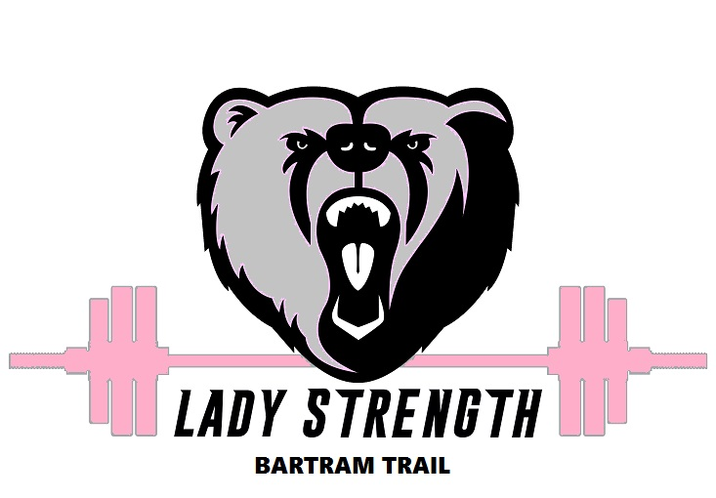

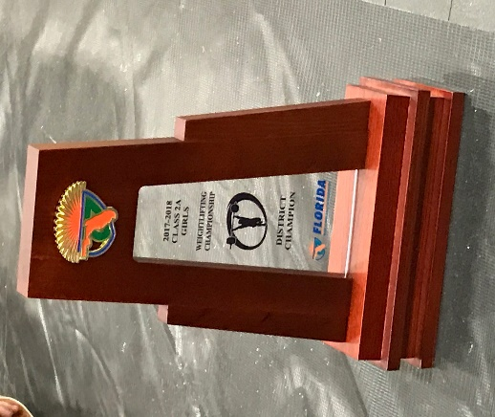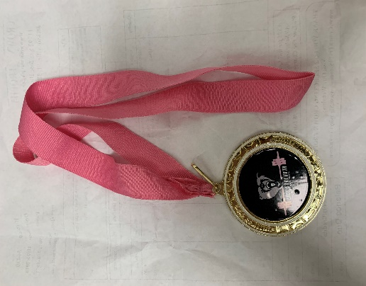

**Informational Meeting**

**Wednesday, September 4th**

**8:50am in Room N126**

**See Coach Reagan for Questions**

**Athletic Clearance Athletic Webpage form Athlete Survey**

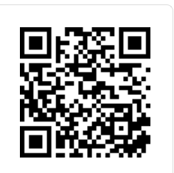 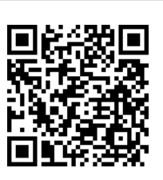

**MUST BE CLEARED BY SEPT. 13 for Pre-season**

**CLEARED BY OCT. 3RD TO TRYOUT!**