Bright Futures & Financial Aid Info

The Florida Bright Futures Scholarship Program establishes lottery-funded scholarships to reward Florida high school graduates for high academic achievement. The program offers three levels of scholarship awards – the Florida Academic Scholars award (FAS), the Florida Medallion Scholars award (FMS), and the Florida Gold Seal Vocational Scholars award (GSV). For complete information, please refer to the Bright Futures Student Handbook, Chapter 1 at https://www.floridastudentfinancialaidsg.org/SAPBFMAIN/SAPBFMAIN.

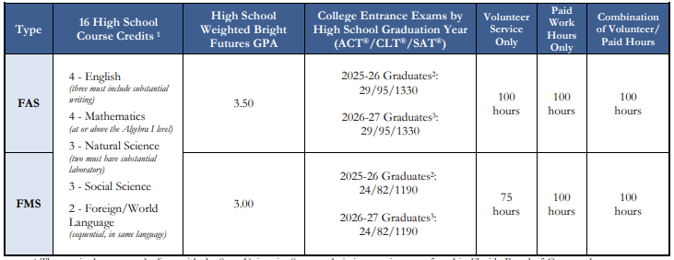

The online application for Bright Futures for the Class of 2026 opened on October 1, 2025!

Initial Eligibility Requirements:
- Submit a complete, error free Florida Financial Aid Application (FFAA) (after October 1 and prior to August 31 after high school graduation),
- Complete the requirements on the chart above (courses, GPA, test scores, service/work hours).
- Bright Futures GPA is not the same as the BTHS GPA; weighting for honors, AP, and dual enrollment classes equally with 0.5 per credit earned; two additional academic electives will be used toward the GPA calculation if it benefits the student.
- Students will be evaluated based on official test scores from the FDOE repository. Test scores must be sent to one of Florida’s public colleges or state universities when registering for the ACT®, CLT®, or SAT®. Students should choose a Florida school when registering for the exam.
- Students have until graduation day to increase their GPA, credits, and service/work hours.
- After submitting the FFAA, the student is responsible for tracking application and award status online and keeping the Office of Student Financial Assistance (OSFA) informed of any changes.
- Enroll in an eligible Florida public or private postsecondary institution.
- Enroll in a minimum of 6 non-remedial semester credit hours per term (or the equivalent)
- If not funded in the academic year immediately following high school graduation, apply within five years of high school graduation to have your award reinstated (must still apply during senior year of HS)
- The Florida Gold Seal Vocational Scholars (GSV) award may be funded if a student is enrolled in a career education or certificate program. (Bright Futures Handbook, Chapter 1: Initial Eligibility.)

Service Hours – Turn in at Mrs. Richards’ desk in Guidance
Students must earn either the required volunteer service, paid work hours, or a combination of 100 total hours. Volunteer hours must be documented in writing, and signed by the student, the student's parent or guardian, and a representative of the organization. Students using paid hours as community service should submit one pay stub showing a minimum of 100 hours. Students must submit a Service Plan for their Bright Futures Community Service Hours and/or work hours to be approved.

