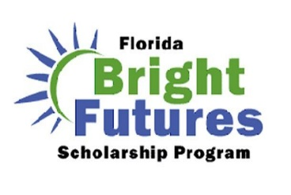
Bright Futures
Info

Seniors, the online application for Bright Futures for the Class of 2021 will open on October 1, 2020! You must complete and submit the application prior to graduation.
Regardless of your current eligibility status, ALL seniors should go on apply. Do not wait to apply until you have met all the requirements. Bright Futures will upload your transcript and service hours in the months of January and June.

Florida high school students who wish to qualify for the Florida Academic Scholars (FAS) award or the Florida Medallion Scholars (FMS) award must meet the following initial eligibility requirements:
- Submit the Florida Financial Aid Application (FFAA) no later than August 31 after high
school graduation,
- Complete the 16 college-preparatory courses required for admission to a state university,
- Achieve the required weighted GPA in the 16 college-preparatory courses per chart below,
- Complete the required number of service hours per chart below, and
- Achieve the required composite ACT or combined SAT score per chart below.

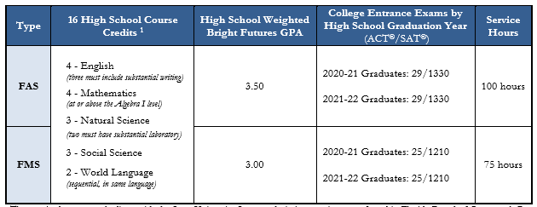

- Bright Futures GPA is NOT the same as report card GPA.
- Bright Futures GPA = 16 credits- Semester grades in approved English (4 credits), Social Studies (3 credits), Science (3 credits), Math (4 credits), and World Language (2 credits) courses only.
- Bright Futures weighs honors, AP, and dual enrollment classes equally with 0.5 per credit earned – NOT 1.0 weight for AP or DE!
- ASL counts as a world language for FL public schools.
- Bright Futures will also accept two additional academic electives toward the GPA calculation if it benefits the student.
- Remember, you have until graduation day to increase your GPA, credits, and community service hours.

~ Further Information on Back ~
High School Course Credits
For both scholarships, the required coursework aligns with the State University System admission requirements. The world language requirement can be met by demonstrating proficiencies based on scores on Credit-By-Exam Equivalencies or other university approved means. Otherwise, the high school transcript must include a world language “completer” course to show that the world language requirement has been met. Please refer to the Bright Futures Course Table for specific information on which courses count toward FAS/FMS requirements.

High School GPA
Evaluation for Bright Futures includes an unrounded weighted high school GPA (calculated to two decimal places) in the 16 college-preparatory credits. The following courses are weighted .25 per semester course or .50 per year course in the calculation of the GPA: Advanced Placement (AP), Pre-International Baccalaureate (Pre-IB), International Baccalaureate (IB), Honors, Pre-Advanced International Certificate of Education (Pre-AICE), Advanced International Certificate of Education (AICE) or academic Dual Enrollment. For example, whereas an ‘A’ equals 4 quality points for an un-weighted course, an ‘A’ would equal 4.5 quality points for a weighted course.
If necessary, students may use two additional credits from courses in the above academic areas, or from AP, IB, or AICE fine arts courses to raise their GPA.

College Entrance Exams
The College Board introduced a new entrance exam (Redesigned SAT®) beginning March 2016.
• The SAT® (SAT administered prior to March 2016) combined score is the sum of the best Critical Reading and Math scores from any test sitting of this version of the ‘Old’ SAT®.
• The Redesigned SAT® (SAT administered beginning March 2016) combined score is the sum or the best Evidence-based Reading and Writing and Math from any test sitting of this version of the ‘New’ SAT®.
• The ACT® composite score is the average of the best scores across the four subject area sections from any test sitting: English, Math, Reading and Science. Composite scores ending in 0.50 will be rounded up to the next whole number.
• The ACT®/SAT® exams may be taken an unlimited number of times through June 30 of the student’s graduation year (or through January 31 for mid-year graduates).
• Request test scores be sent to one of Florida’s 12 state universities, Florida state colleges (public community colleges), or public high schools when registering for the ACT®/SAT® so that test scores will be sent to the Florida Department of Education (FDOE) repository.

Service Hours – Turn in to Mrs. Richards in Guidance
Students must complete volunteer service hours during high school and by high school graduation. Service hours may include, but are not limited to, a business or governmental internship, work for a nonprofit community service organization, or activities on behalf of a candidate for public office. The hours must be documented in writing, and signed by the student, the student's parent or guardian, and a representative of the organization. Each public school district and private school establishes approved activities and the process for documentation of service hours.
Please refer to the Bright Futures Student Handbook at https://www.floridastudentfinancialaidsg.org/PDF/BFHandbookChapter1.pdf

