Alertus Mobile App Instructions – Android Devices

- Go to the Play Store.
- Search for Alertus. For the below app
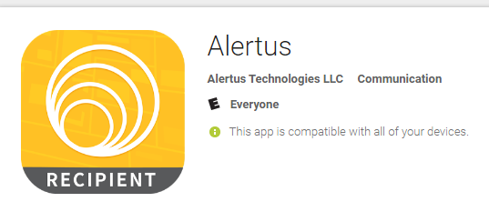

- Install Alertus.
- Once it is installed, open the app to finish setup.
- The app will ask for an Organization Code
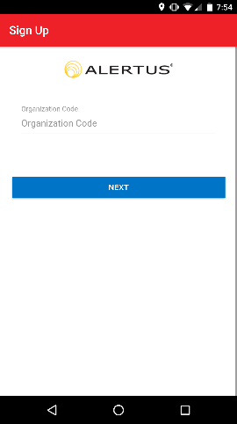

- Enter “SJRSTATE” (not case sensitive) and select “Next”
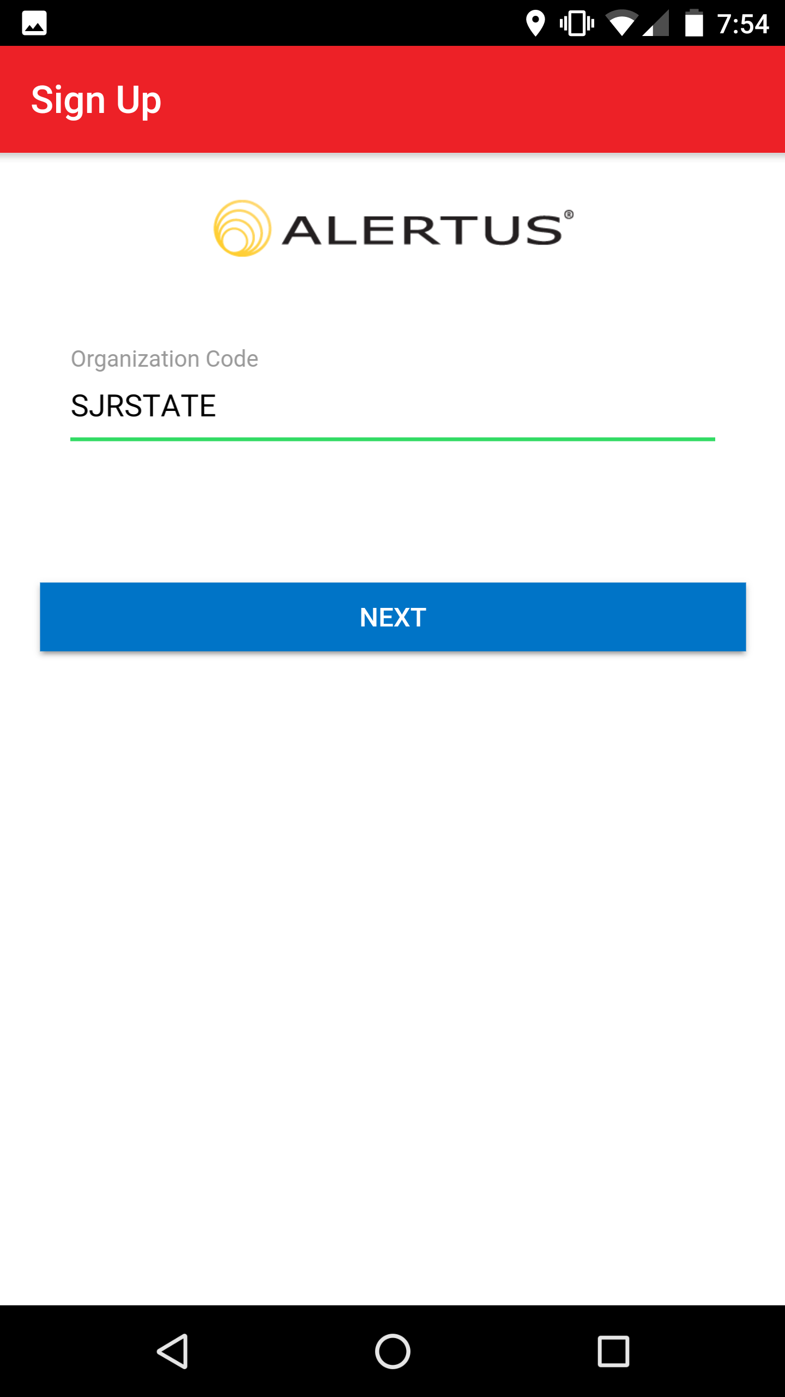

- Enter your SJR State email address and select Register.
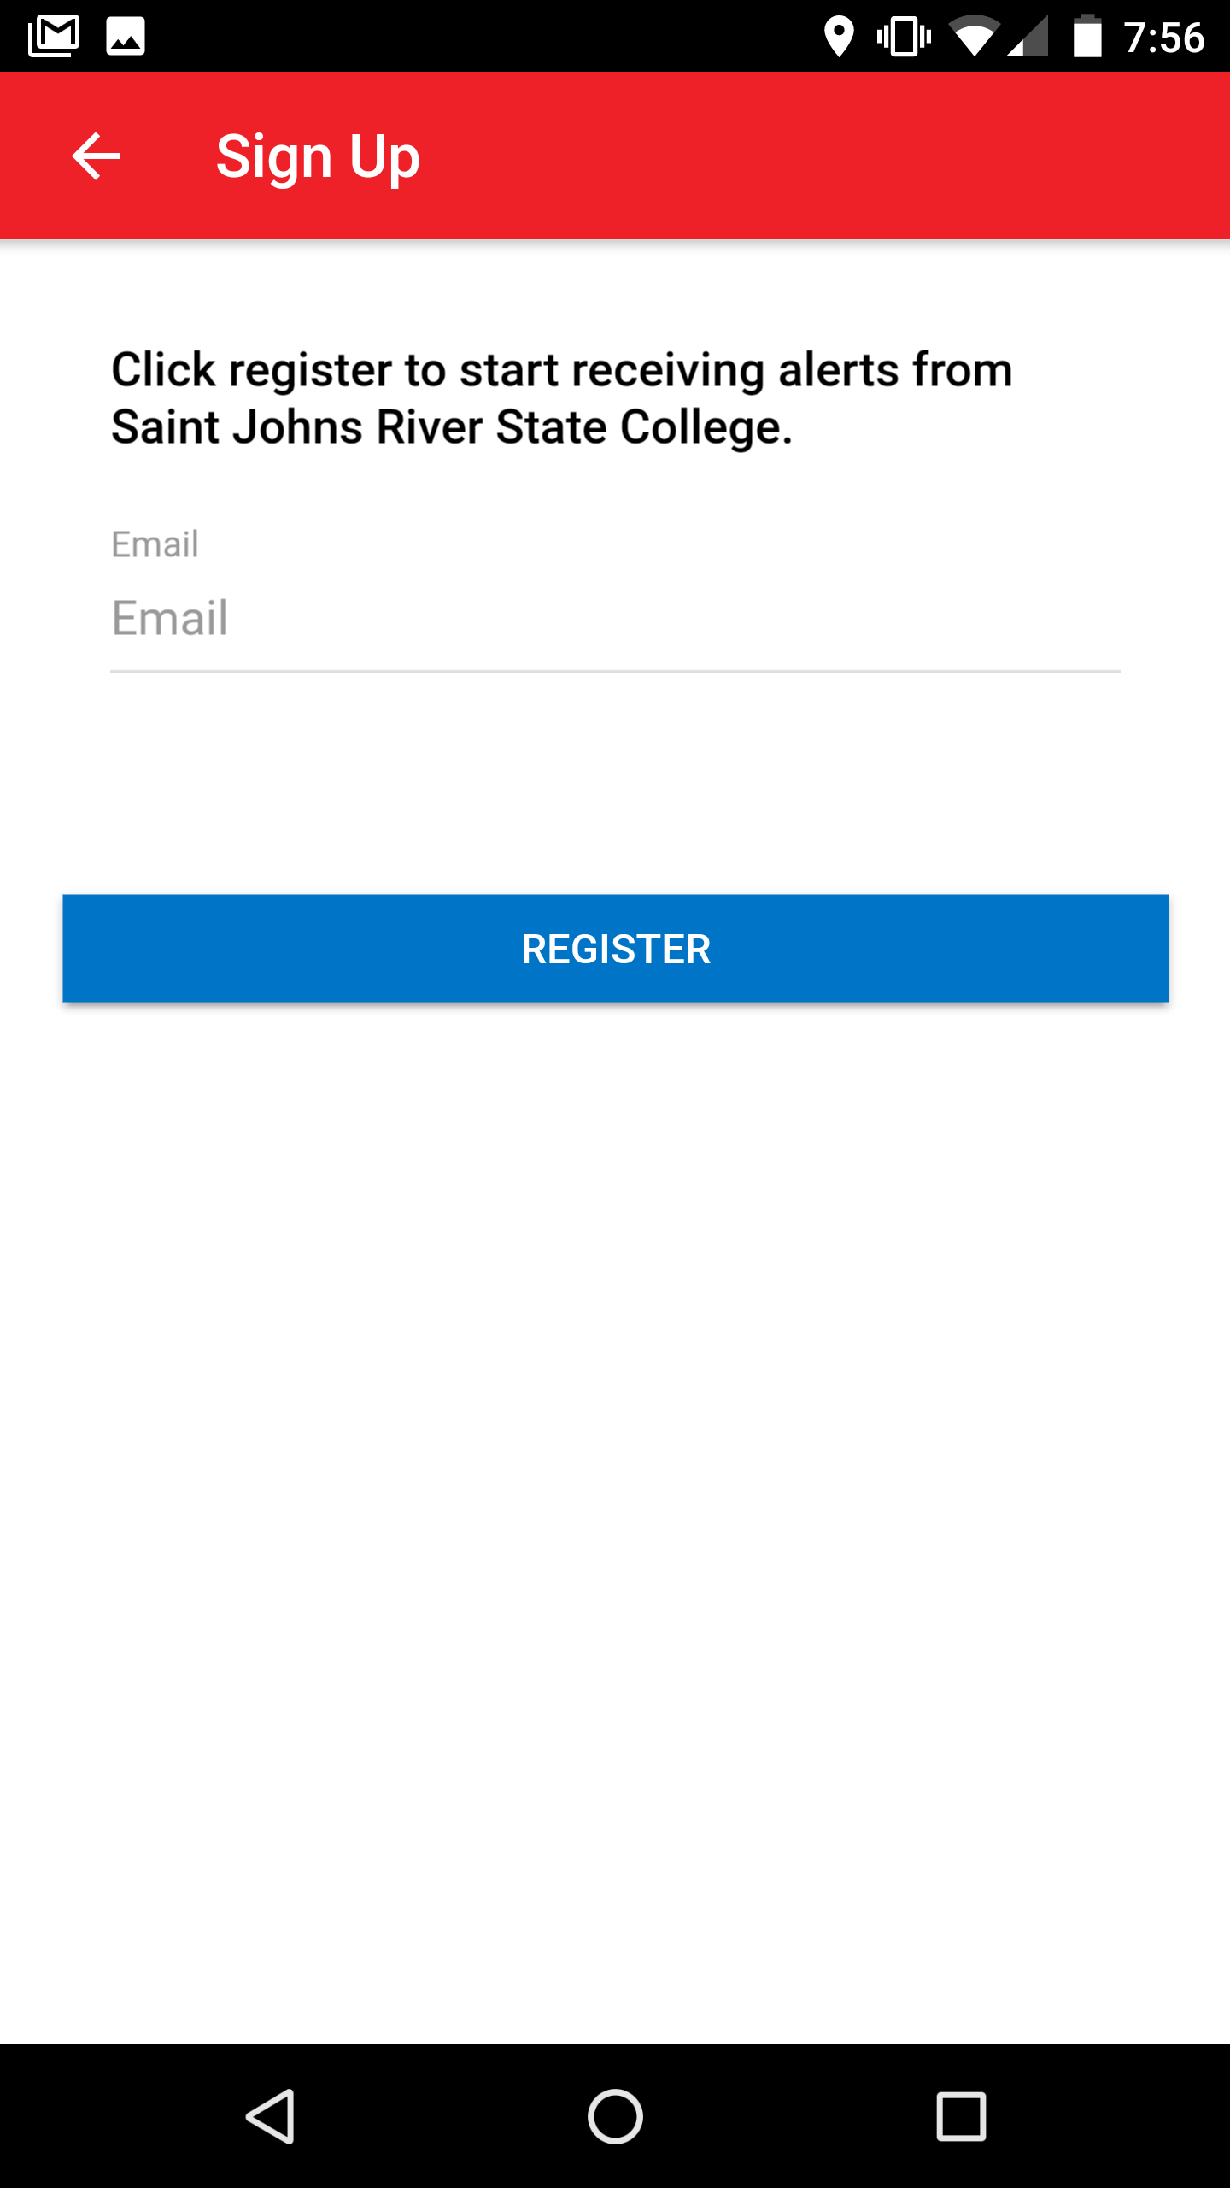

- An email will be sent from noreply@mobile.alertus.com to your SJR State email address. Follow the instructions in the email and click on the link provided.
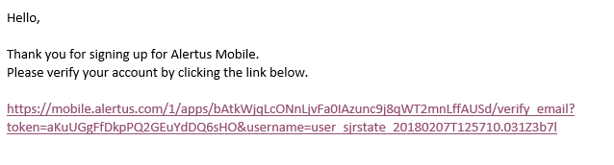

- The link will provide a success message.
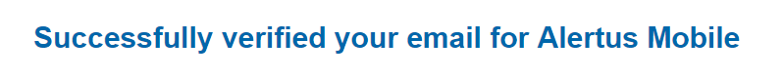

- Complete the mobile app setup by hitting Email Verified.
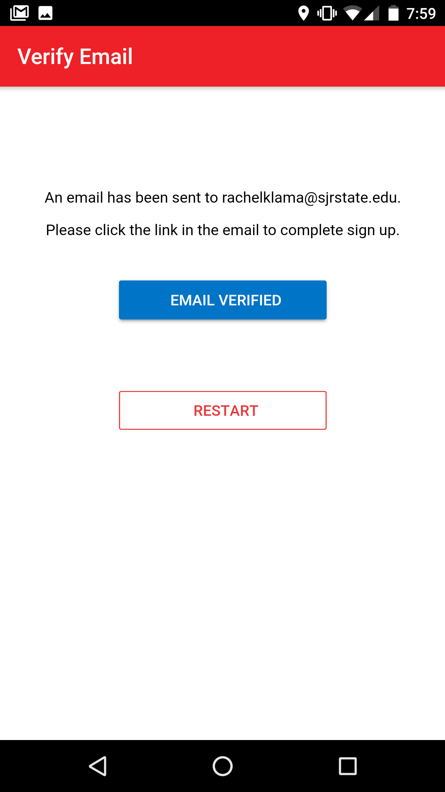
Note: Allow Alertus to send notifications. You do not have to allow Alertus to use device location.

- Go to My Subscriptions
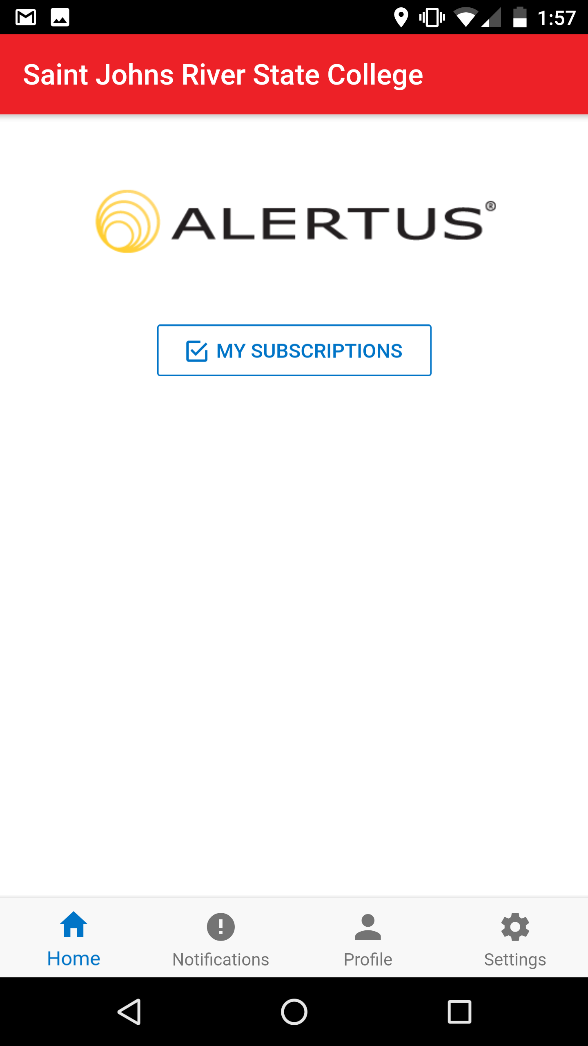

- Subscribe to campuses
