BARTRAM TRAIL HIGH SCHOOL FOOTBALL ALUMNI -Student / Athletes don’t leave the BT Football Program – THEY ARE SENT. They are sent with a mission: to positively impact the world around them.
Below is a list of Bears who have, or currently are, making their college football programs and campuses better because of their involvement.
Class | Name | Position | School
2019 | Gunnar Hitzeman | WR | 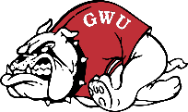  Gardner-Webb
 | Griffin Helm | SB | 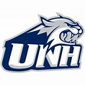  University of New Hampshire
 | Devin Ellison | RB | Georgia Tech 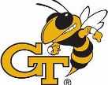
 | Collin Mckee | OL | The Apprentice School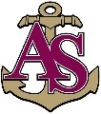
 | Johnny Burkett | OL | Dodge City Community College
 | Spencer Judson | OL | Webber International
 | Harry Bowker | DB | Mount Union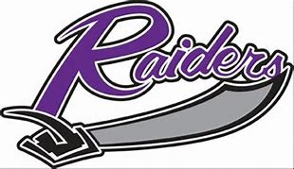
 | Robby Love | DT | Fort Scott Community College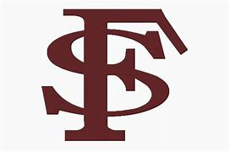
2018 | Joey Gatewood | QB | Auburn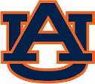
 | Xavier Hutchinson | WR | Blinn Community College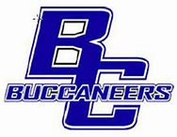
 | Corbein Hagans | OLB | Independence Community College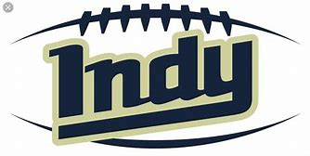
 | Olivier Pageotte-Andre | LB | Robert Morris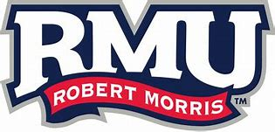
 | Riley Smith | QB | Boise State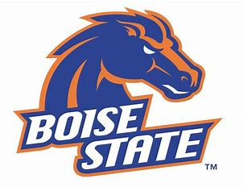
 | Jake Navin | WR | Stetson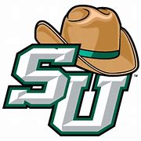
 | Robert French | TE | Rice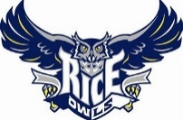
 | Josh Follenweider | DB | Tufts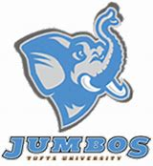
 | Kaelen Skipper | DB | FAU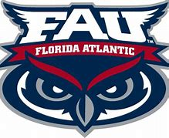
 | Johnny Amell | LB | Navy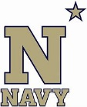
 | Austin Murray | DE | Baldwin Wallace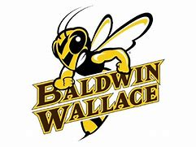
 | Brad Cecil | OL | University of South Florida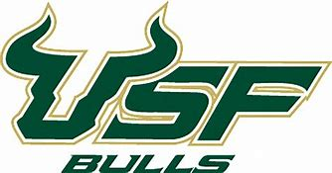
 | Parker Devine | DE | Georgia Southern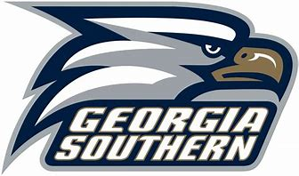
 | Kolton McDaniel | DT | Trine
2017 | Chandler Harvin | WR | Sam Houston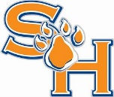
 | Cole Davis | OLB | University of South Carolina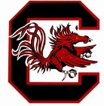
 | Connor Aston | RB | Berry College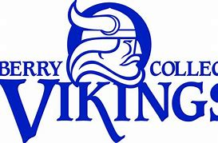
 | Will Newman | LB | Rhodes College
 | Andrew Mims | LB | University of South Florida
 | Tyler Gilroy | LS | FSU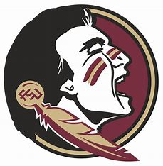
 | Gary Breuklander | TE | Tusculum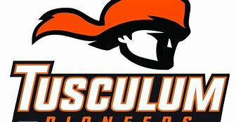
 | Jordan Smith | QB | Gardner-Webb
2016 | David Coleman | RB | Florida Tech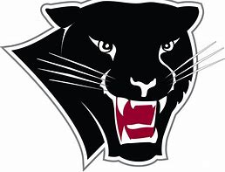
 | Bryce Walker | WR | Palomar College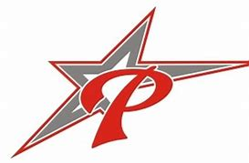
 | Jordan Helm | Safety | Florida Atlantic University
 | Amaru Spence | DB | North Carolina Wesleyan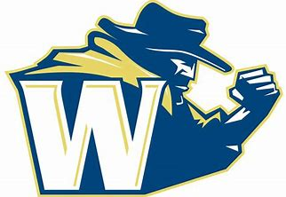
 | Michael Clarke | OLB | Bentley College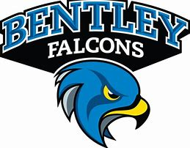
 | Jared Nourse | OL | FAU
 | AJ Bolden | WR | New Mexico Military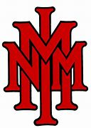
2015 | Elijah Casey DL |  | Jacksonville University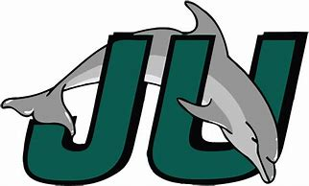
 | Anthony DeLeo | DB | Florida Atlantic
 | Hunter Hartsfield | OL | Jacksonville University 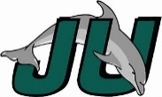
 | Hayden Good | LB | Johns Hopkins 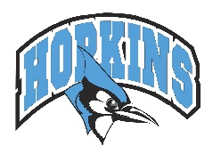
 | Jake Marshall | DB | Northwest Missouri State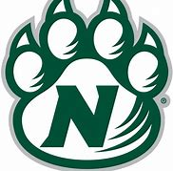
 | Nick Martin | DL | Davidson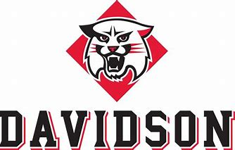
 | Tyler Mechley | OL | Mt St Josephs 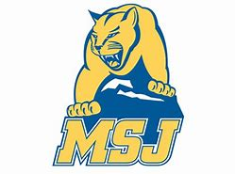
 | Luis Sobh | DL | West Florida 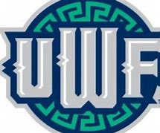
 | Angel Toyens | RB | University of West Florida
2014 | Jesse Burkett | OL | Stanford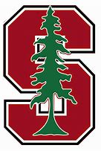
 | Romello Bentley | SLOT | Nebraska Kearney 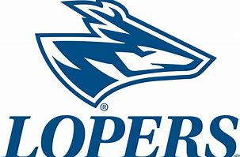
 | PJ Blazejowski | QB | Furman 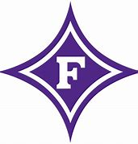
 | Travis Boller | BB | Trine
 | Karl Harris | WR | Cumberland
 | Travis Keller | OL | Stetson
 | Ryan Magden | RB | Methodist
 | Malik Rivera | LB | Wofford / Graduate Georgia Tech
 | Will Tillo | LB | Southeastern
2013 | Gabe Davis | RB/WR | Webber State 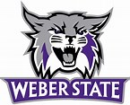
 | Parker Davis | WR | Anderson
 | Tylar Reagan | OL | NC State 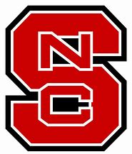
2012 | Matthew Amell | DB | 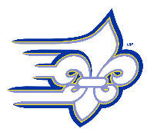  Limestone
 | Matthew Arnwine | TE | Samford 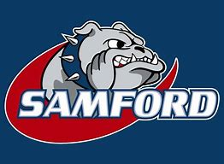
 | Jolen Briggs | DB | Western Kentucky 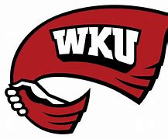
 | Jared Crump | WR | Wake Forest
 | Hayden Garlipp | DL | Minot State 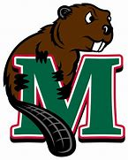
 | Korey Harris | DE | West Virginia 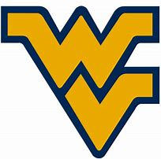
 | Gabe Johnson | RB | Charleston Southern 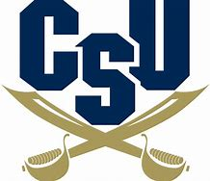
 | Cole Leininger | K/P | California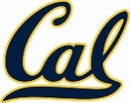
 | Matt Mailhot | LB | Defiance 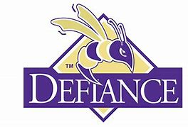
 | Samson Moeakiola | DL/LB | Ferrum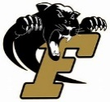
 | Nathan Peterman | QB | Tennessee / Graduate: Pittsburgh 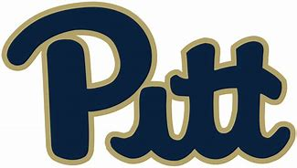
 | Bobby Walker | WR | Troy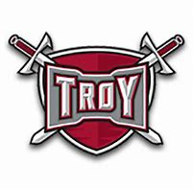
2011 | Brion Anderson | DB | Wofford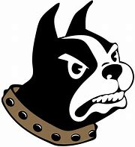
 | Jeff Lindenmoyer | OL | Ave Maria 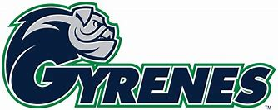
 | Jon Roach | OL | Wingate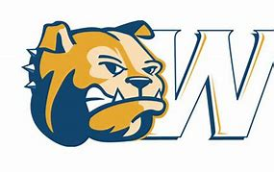
2010 | Blake Parrish | OL | Wingate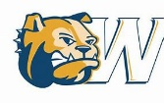
 | Derrick Taylor | RB | Charleston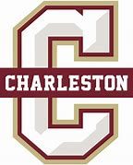
 | Danny Sellers | WR | Elon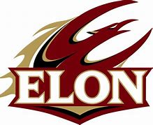
2009 | Alex Douglas | DB | Dartmouth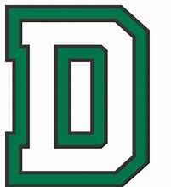
 | Jason Young | QB | Tiffin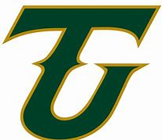
 | Kory Burnett | DB | Florida State
2008 | Charles Bailey | WR | Mississippi State 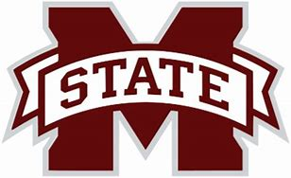
 | Xavier Brewer | DB | Clemson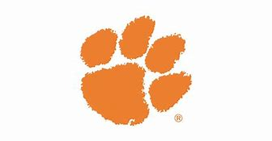
 | Christian DeTrude | DL | Jacksonville University
 | Grant Harner | OL | East Carolina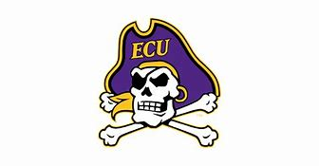
 | Taylor Johnson | RB | Taylor
 | Damon Lawrence | DB | Presbysterian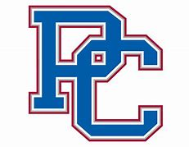
 | Darius Lawrence | DB | Tiffin
 | Andrew Parker | TE | Wake Forest
 | Kyle Parker | QB | Clemson
 | Mark Safer | RB | Springfield College 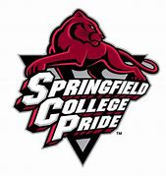
 | Trey Sumner | LB | Florida State
 | John Watts | DL | LaGrange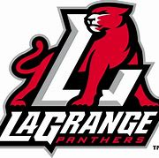
 | Xavier Zayas | WR | Tiffin
2007 | Thomas Edenfield | OL | Southern Mississippi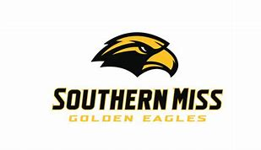
 | Wynn Stinespring | WR | Georgia Southern
2006 | Chrys Bishop | QB | Methodist
 | Chad Guinn | LB | Wingate
 | Zach Handerson | OL | North Carolina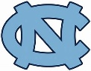
 | Jon Malandrucco | DB | McKendree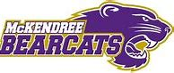
 | Joel Raggins | RB | Grambling State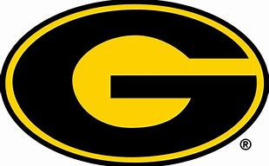
 | Josh Culbreth | DE | Carson-Newman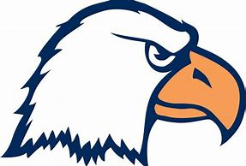
2005 | Jeff Griffin | OL | Wake Forest
 | Brandon Bishop | OL | Jacksonville University
 | Chris Romani | DL | West Virginia Weslyan
2004 | Steven Briggs | WR | Alabama State
 | George Smith | RB | McKendree
 | Josh Sanfilippo | QB | Southern Arkansas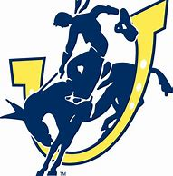
 | Justin Treece | DL | Wofford
2003 | Mac Grossman | TE | Jacksonville University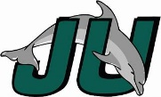
 | Jay Malandrucco | DB | Geneva
 | Bryan Orenchuk | RB | Central Florida 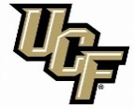
 | Luke Sanfilippo | WR | Jacksonville University 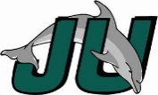
2002 | Justin Eason | DL | Jacksonville University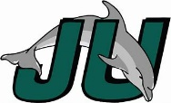
 | Jeff Malandrucco | QB/LS | Bethune Cookman 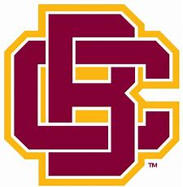
2001 | Jacob Pearman | DL | Chowan 