Bartram Trail High School
2019-2020 Expedition Volume 20
Yearbook Staff Application

Dear Applicant:

We appreciate your interest in becoming a member of the 2019-2020 Bartram Trail Yearbook Staff. Performing as a part of yearbook is a large responsibility; so we are looking for the best students to join our staff. Please consider the following when applying: staff members plan and create the entire yearbook from cover to cover under student and advisor leadership. The creation of our book is fast-paced and deadline-driven. As a member of our staff, you may have to work after school and/or during lunches to meet deadlines as needed. You may also have to attend after school events in order to take pictures. The production of the yearbook is a lot of work, but it is also a lot of fun and will provide you with real-world experience.

Potential staff members are expected to:
- Have strong writing skills
- Be highly organized
- Have good attendance
- Possess a strong work ethic
- Have a positive attitude
- Be a Plan B thinker (There is no acceptance of apathy or irresponsibility. Do you want to be responsible for a blank, white page in a $100k+ yearbook?)

If you are interested in becoming a member of our staff, please complete the attached three-part application. Applications must be turned into Ms. Irwin in Room 845 by Friday, January 18th. Once applications are reviewed, you will be contacted for an interview with the advisor, Ms. Irwin, and next year’s editor-in-chief.

Thank you for your interest, and we are excited to review your application. Good luck!
Sincerely,

Anne Irwin

Anne Irwin
Yearbook Advisor

Name: _____________________________________
Grade for the 2019-2020 School Year ________________________

Why do you want to be a member of the Bartram Trail yearbook staff?

In what other extracurricular activities do you plan to participate next year?

Are you willing to make yearbook one of your top priorities? YES NO
Are you willing to work after school and during lunch to meet
deadlines as needed? YES NO
Why are deadlines important?_________________________________________________________________________________________________________________________________________________________________
Are you willing to attend after-school events and games in order
to report about them and/or take photos? YES NO
Can you handle constructive criticism from student editors and the advisor? YES NO
Are you comfortable using digital cameras? YES NO
Are you comfortable interviewing people you may not know? YES NO

Please number these activities in the order that they interest you most.
___ Interviewing People
___ Writing Copies
___ Taking photos
___ Design

Please provide us with your current schedule along with full teacher names.
1st __________________________________________________________________________________
2nd _________________________________________________________________________________
3rd __________________________________________________________________________________
4th ___________________________________________________________________________________
5th ______________________________________________________________________________
6th __________________________________________________________________________________
7th __________________________________________________________________________________

I. COPY WRITING
Please write a copy that would be appropriate to appear in a yearbook. The copy should be about a BTHS sports team. (The story does not have to be factual.) The copy should “tell a tale.”
Guidelines:
- Your copy should be 150-200 words in length, written in 3rd person, past tense
- Include direct quotes from at least 3 players that help support the tale. These do not need to be factual, but be sure that they make sense and flow throughout your copy. They should be well developed.
This copy should reflect your best work; so be sure to double check your spelling, grammar, and verb tense. Your copy should also be turned in typed and printed. The lead in sentence should be present tense, and then all other sentences should be past tense.

II. CAPTION WRITING
Imagine that you have been asked to write the caption for the following pictures.

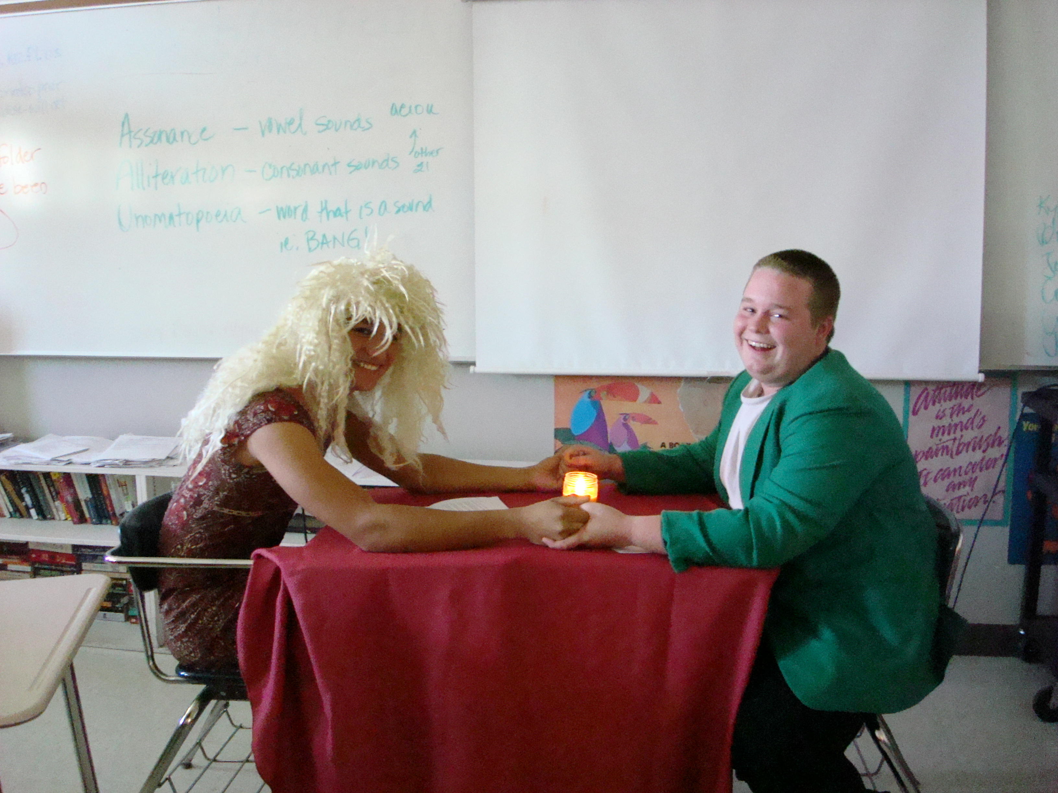

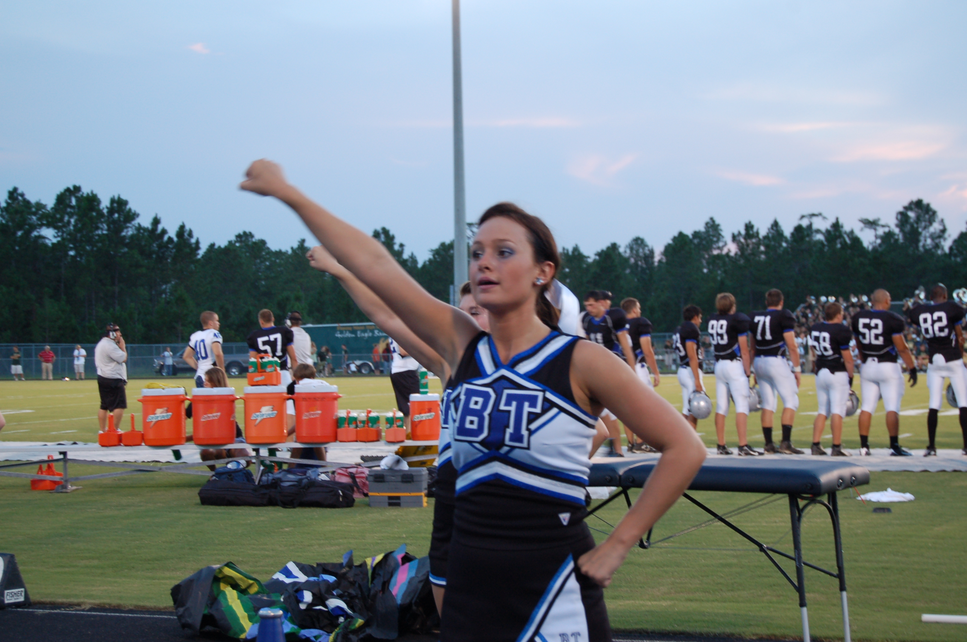

The formula for caption writing is as follows:
The 1st sentence describes who, what, when, where, why, and how and is written in the present tense.
The 2nd and/or 3rd sentence includes a quote from one of the people pictured and another detail about the picture. It is written in the past tense. Please type and print captions. You may use a fake name and artificial details about the event as long as the elements are present.

III. WHAT WOULD YOU DO?
Please answer the following questions about how you would deal with each situation. Type and print your answers to include with the rest of your application.
- You are in charge of the JV football layout. Tonight is the last game of the season and you find out that only 3 of the pictures that you have are usable. What do you do? Adjusting the layout is not an option.
- The deadline for your student life layout is 3:00 this afternoon. It is noon and two of your captions still do not have names and quotes. What do you do?
- You are responsible for getting in contact with a coach of a sport who is not an employee at Bartram Trail. You go to Mrs. Evans’s office to find a way to contact this coach, and she is not there. What do you do?

ACKNOWLEDGEMENT AND SIGNATURE FORM
Performing as a member of the Bartram Trail Yearbook Staff is a privilege as well as a major commitment. Staff expectations:
- Work as a team
- Learn to use appropriate technology including but not limited to Microsoft Word, Adobe Photoshop, eDesign, and digital cameras
- Write copies, conduct interviews, and take photos as assigned
- Work after school and/or during lunch to meet deadlines as needed
- Help sell yearbooks, work picture days, misc. yearbook related activities
- Come to class prepared with all assignments everyday and meet deadlines
Missed deadlines cost thousands of dollars.
- Keep a positive attitude and realize that this is a rewarding job, but not all days are filled with rainbows and butterflies.
I understand that working on the Bartram Trail yearbook staff is a major commitment.
If selected, I acknowledge that I will be assigned to interview people, write copies, and take photos.
I understand that I will sometimes need to work after school and/or during my lunch to meet deadlines.
I will be responsible for finishing my assigned yrbk duties; efficiently and on time determines my grade.
I will not leave work unfinished for others to have to complete.
I will use constructive criticism from the advisor and editors to create the best copies and layouts I can.
I will be evaluated on my assignments and layouts for accuracy, creativity, adherence to guidelines, and meeting deadlines.

Student Signature
I understand that if my son/daughter is selected to be a member of the Expedition staff, he/she is committing to work hard everyday in class, stay after school as needed, and attend school events as assigned. I support my child in this endeavor and realize the importance of met deadlines.

Parent Signature

