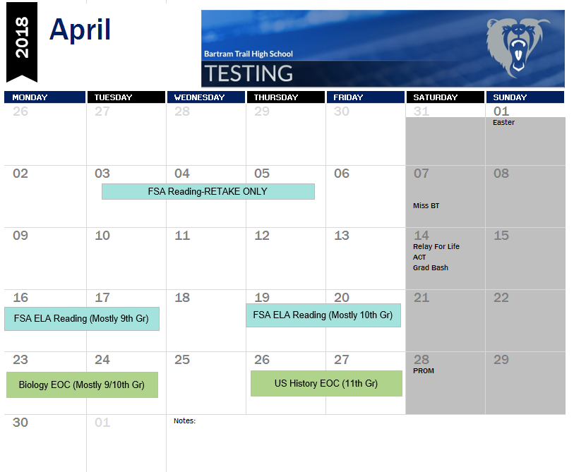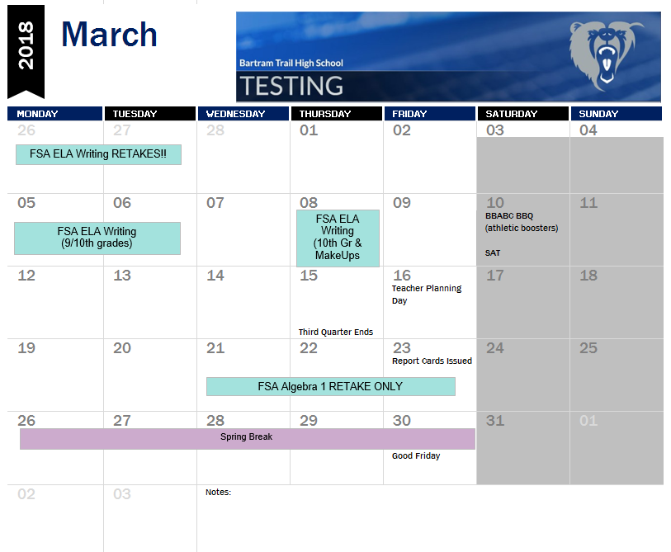

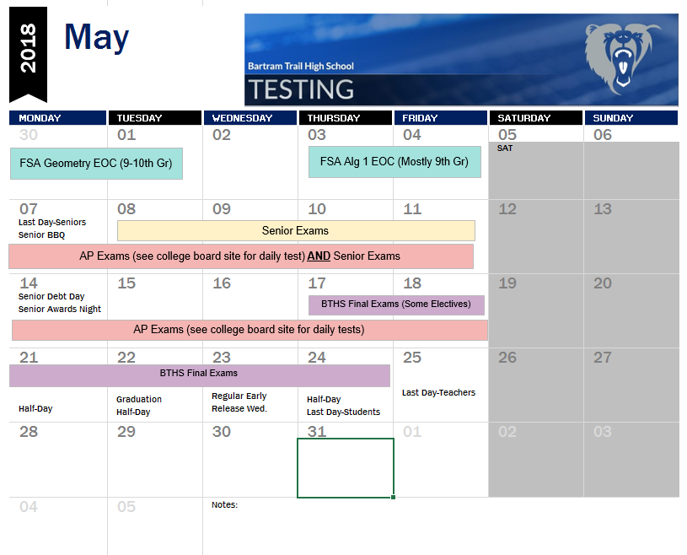

**Testing Notes:**

* Please contact your teacher for Dates/Times/Locations of various tests - OR – visit the BTHS Testing page via the BTHS Website
* Final Exam Schedules are available on the BTHS Testing page as well.
* As always, please be considerate of this time of year when scheduling appointments or travel.
* Please email Haley Jasper (testing coordinator) with any questions [haley.jasper@stjohns.k12.fl.us](mailto:haley.jasper@stjohns.k12.fl.us)
* BTHS Testing Page: <http://www-bths.stjohns.k12.fl.us/testing/>